**Create new directories for new drop**

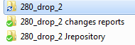

**Get new views from repository**

**Connect DK**

**TEST FTST tmdtwrk1 (212.45.180.88 tmdtwrk1)**

**cd raviv/viewFiles**

**mkdir 280_drop_2**

**cd 280_drop_2**

**copy from right storage A B or C the views:**

**cp /tmdstg/TMD_A/lib/*c32_v.v .**

**cp /tmdstg/TMD_B/lib/*c32_v.v .**

**cp /tmdstg/TMD_C/lib/*c32_v.v .**

**Connect NO**

**Host: tuxtst (212.45.180.173)**

**User: ntcntux1**

**Pass Amdocs**

**cd raviv/viewFiles**

**mkdir 315_drop_1**

**cd 315_drop_1**

**cp /ntcstg/NTC_A/lib/*c32_v.v .**

**cp /ntcstg/NTC_B/lib/*c32_v.v .**

**cd /ntcstg/NTC_B/lib**

**and:**

**cd /ntcstg/NTC_B/applib**

**cd /ntcstg/NTC_A/applib**

FTP from Unix to windows :

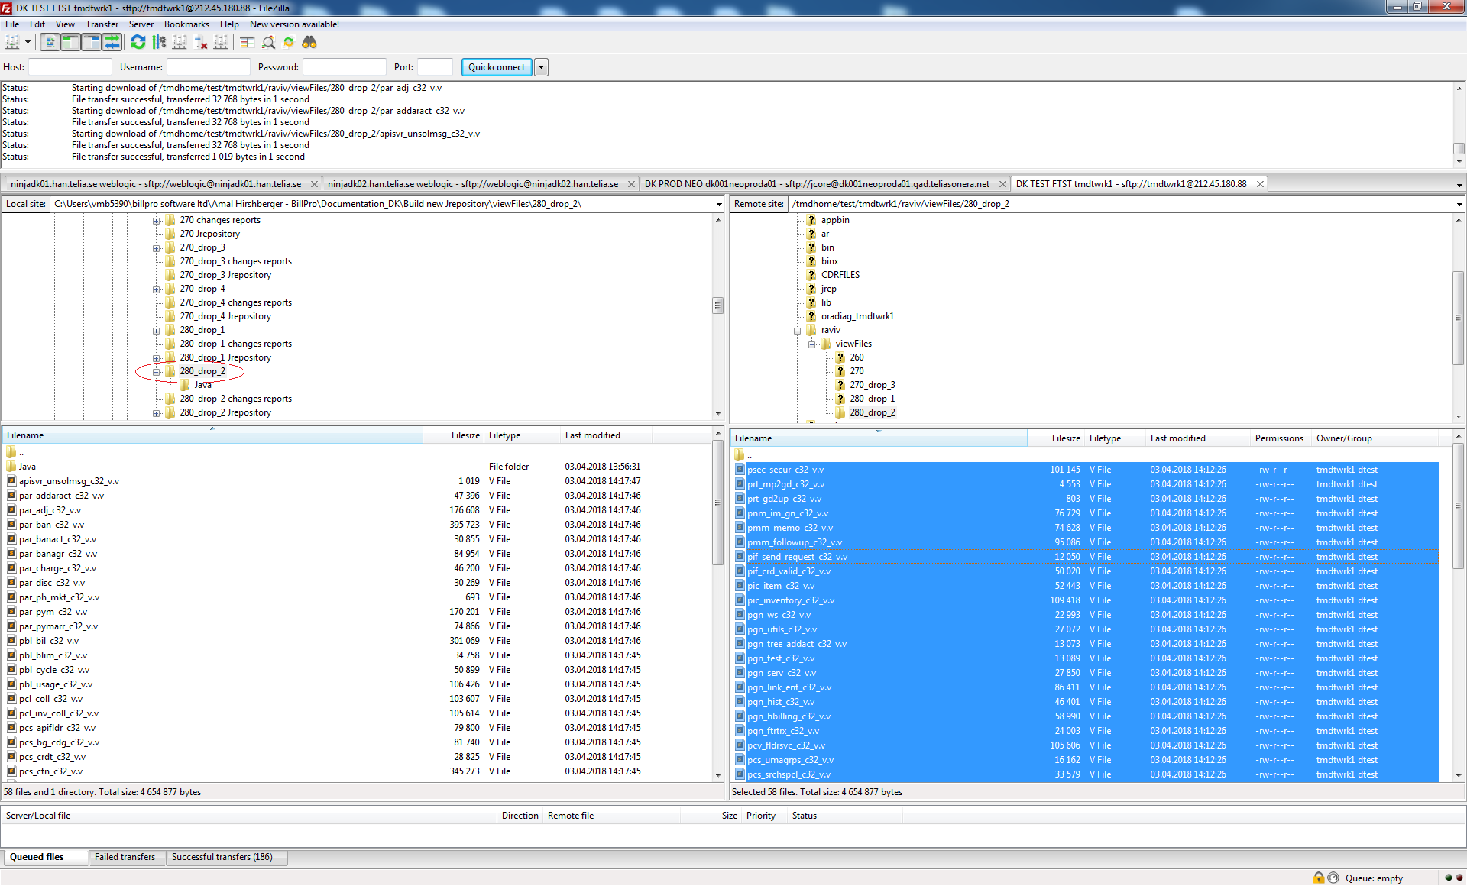

Update Fokus drop

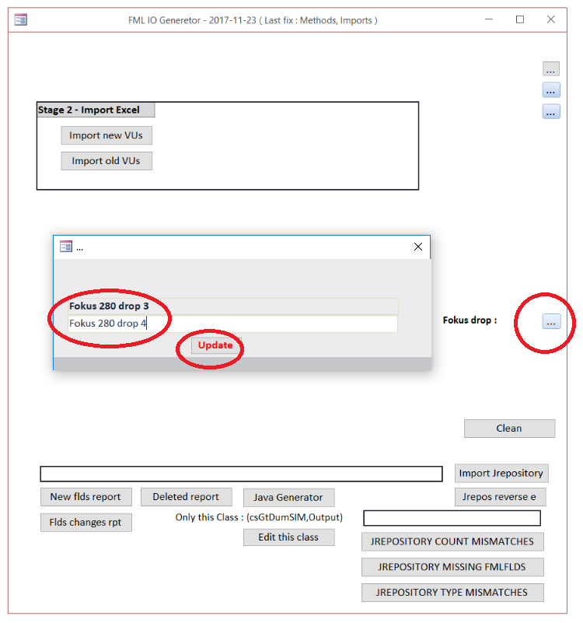

Import old views – watch status bar for progress:

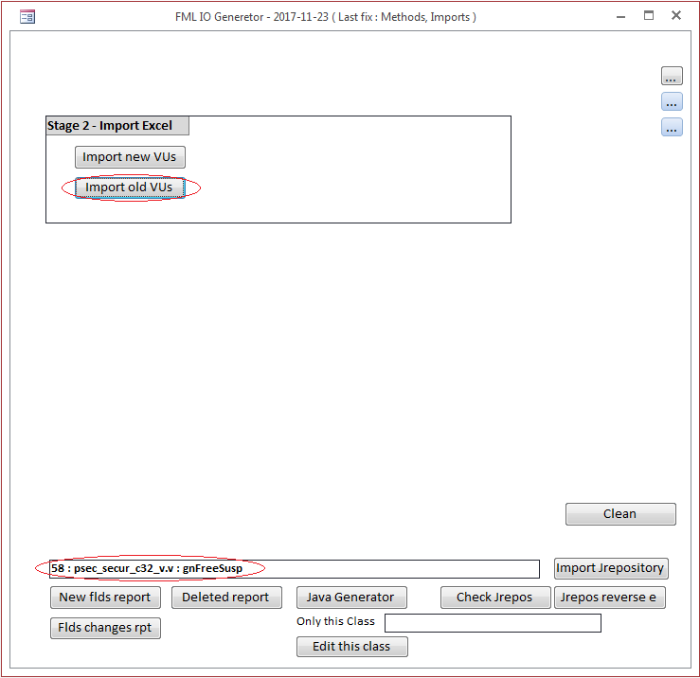

Import new views – watch status bar for progress:

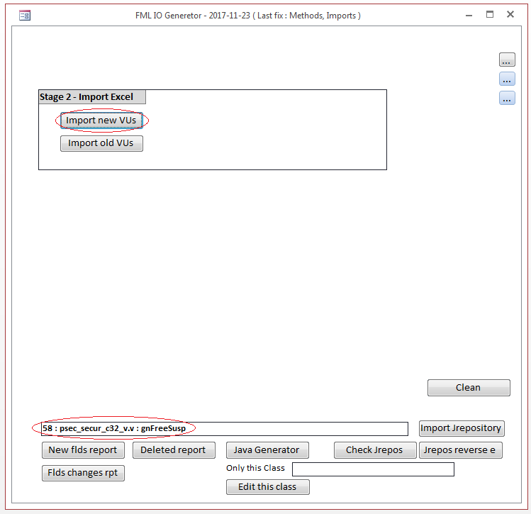

New fields report:

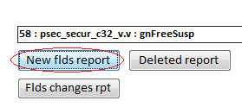

Excel:

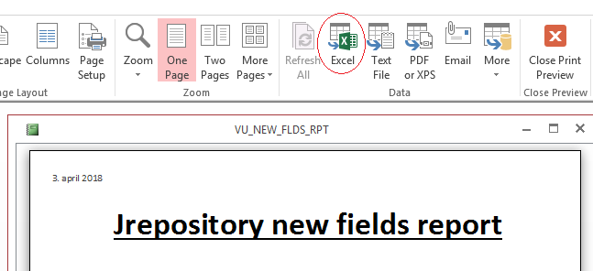

Save under:

Build new Jrepository\viewFiles\280_drop_2 changes reports

Changes report:

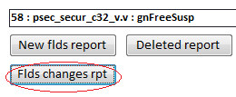

**Update Jrepository**

C:\bea\tuxedo8.1\NinjaJoltEditor

Git bash

. ./setenv.sh

export TUXDIR=/C/bea/tuxedo8.1

export APPDIR=/C/bea/tuxedo8.1/NinjaJoltEditor

export PATH=$TUXDIR/bin:$APPDIR:$PATH

export TUXCONFIG=$APPDIR/tuxconfig

export LANG=C

vmb5390@8CG542209JC0FF MINGW64 /c/bea/tuxedo8.1/NinjaJoltEditor

$ tmboot -y

C:\bea\jolt

Git bash

./run_applet.sh

127.0.0.1

7001

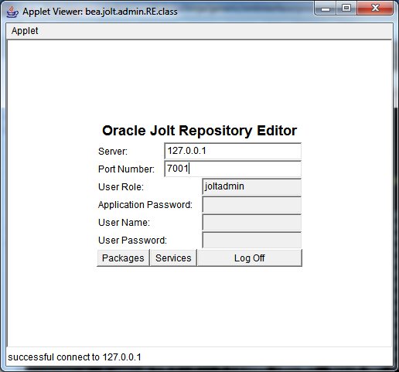

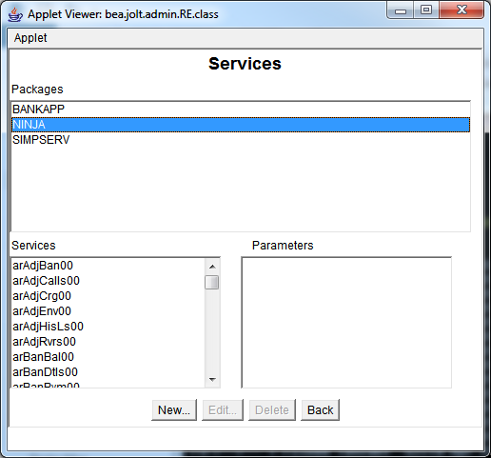

Update according to changes reports …

"string” -> "TYPE_STRING"

"long" -> "TYPE_INTEGER"

"char" -> "TYPE_BYTE"

"short" -> "TYPE_SHORT"

"double" -> "TYPE_DOUBLE"

"carray" -> "TYPE_BYTE_ARR"

Log out when done

vmb5390@8CG542209JC0FF MINGW64 /c/bea/tuxedo8.1/NinjaJoltEditor

$ tmshutdown –y

**Verify Jrepository file**

Copy jrepository_Telia

From C:\bea\tuxedo8.1\NinjaJoltEditor

To …\viewFiles\280_drop_2 Jrepository

Copy and rename to jrepository_Telia.txt

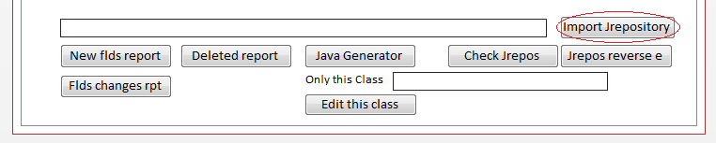

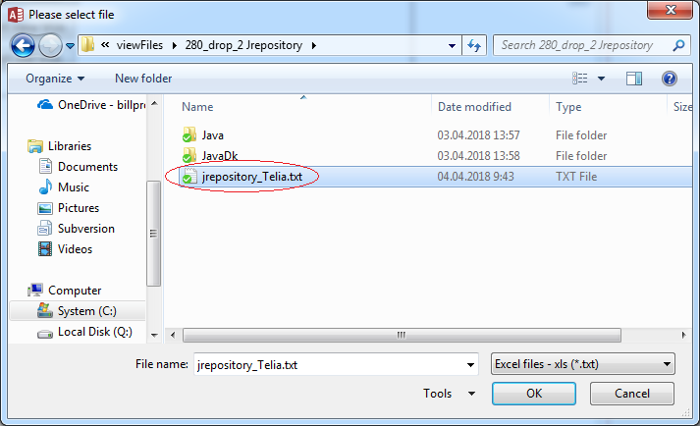

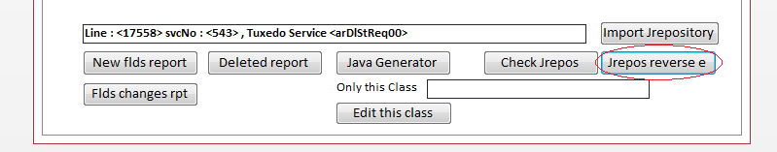

You can monitor Status bar for progress

Check for mistakes in Jrepository:

